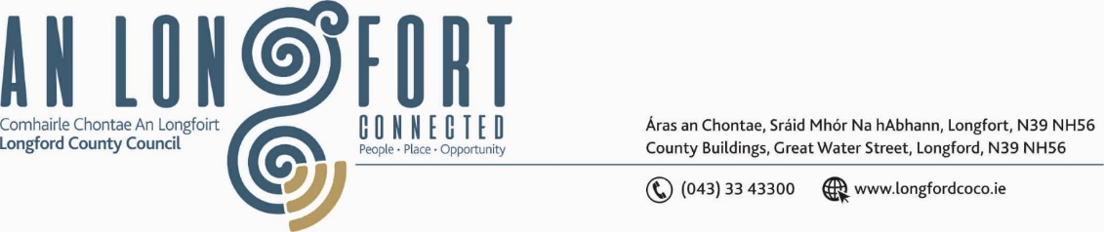

**GRANARD MUNICIPAL DISTRICT**

***Please note meeting will be held in the Council Chamber and via Microsoft Teams.***

**17 October 2023**

**To: Each Member of Granard Municipal District.**

**Dear Member,**

You are requested to attend a Meeting of Granard Municipal District to be held in the Council Chamber and **via Microsoft Teams** on **Tuesday** **24 October 2023 at 3.30pm** to transact business, as set out on the Agenda hereunder.

**Yours sincerely**,

______________________

**Claire McNabola,**

**Meetings Administrator.**

**AGENDA**

Prayer before meeting.

**1.** Consideration of the 2024 General Municipal Allocation.